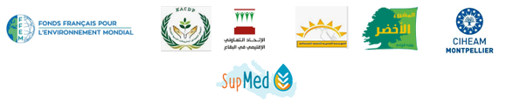

Training Session on the Use of Bio-economic Models for Agricultural Extension – Lebanon
SupMed project
Baalbek, 28-29 October, 2021
- Objectives
The SupMed project aims to improve farmer’s resilience in Luxor (Egypt) and the Baalbek-Hermel (Lebanon) regions to climate change and market uncertainty. For this, the project will, in close interaction with local stakeholders, propose implement and evaluate agro-ecological practices and their socio-economic impacts.
Few researchers today are trained in the concept of bio-economic modeling applied to agricultural extension and consulting. A training session will be organized for local researchers to be familiar with bio-economic modeling, and its potentials at the local level. This compromises analysis of relevant indicators and database management, in response to climate change threats, primarily drought. Research study cases done at the international as well as the national level will be presented.
Participants in the session are researchers working with national research and academic entities as well as selected key persons working with development projects active in the region.
- Program
Day 1: Training session chaired by Dr Mohamed El Khansa
09:00-10:00 : Brief Introduction to SupMed project.
10:00-10:20 : Coffee Break.
10:20-12:00 : Bio-economic Modeling (BEM) in Agriculture: Concept and local examples.
12:00-13:00 : Lunch Break.
13:00-15:00 : Farmers' Typology: Understanding the characteristics of different framers groups.

Day 2: Training session chaired by Dr Mohamed El Khansa
09:00- 10:30 : Scenarios in BEM: Testing proposed solutions for actual problems.
10:30-11:00 : Coffee Break.
11:00- 13:30 : Identification of Mitigation and Adaptation Options to Climate Change within the Local Context (Groups Exercise).
End of training

