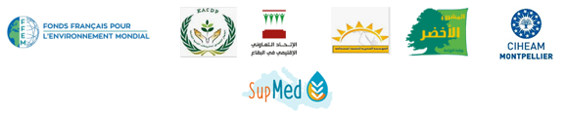
Training Session on the Use of Bio-economic Models for Agricultural Extension – Lebanon
SupMed project
Baalbek, 19-20 October, 2021
- Objectives
The SupMed project aims to improve farmer’s resilience in Luxor (Egypt) and the Baalbek-Hermel (Lebanon) regions to climate change and market uncertainty. For this, the project will, in close interaction with local stakeholders, propose implement and evaluate agro-ecological practices and their socio-economic impacts.
Few researchers today are trained in the concept of bio-economic modeling applied to agricultural extension and consulting. A training session will be organized with concrete cases for local actors to take part in bio-economic modeling at local level. This compromises analysis of relevant indicators and database management, in response to climate change threats, primarily drought.
Participants in the session are key persons of the water users associations (WUA) managing the three hill lakes in the SupMed project focus area (Nahleh, Medwi, and Bouday), in addition to leaders of the Union of Cooperatives in Bekaa. Selected agriculture extension engineers working in the Baalbek-Hermel area will also be invited to attend.
- Program
Day 1: Training session chaired by Dr Mohamed El Khansa
09:30-10:00 : Brief Introduction to SUPMED.
10:00-12:00 : Bio-economic Modeling (BEM) in Agriculture: Concept and local examples.
12:00-12:30 : Coffee break
12:30-14:30 : Farmers' Typology: Understanding the characteristics of different framers groups.
14:30-15:00 : Lunch

Day 2: Training session chaired by Dr Mohamed El Khansa
09:00- 10:00 : Scenarios in BEM: Testing proposed solutions for actual problems.
10:00-10:15 : Coffee break
10:15- 13:30 : Identification of Mitigation and Adaptation Options to Climate Change within the Local Context (Group Exercise).
13:30-14h00 : Lunch
End of training

