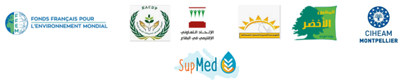
Training Session “The importance of bio-economic modelling for building resilient agricultural systems” – Egypt SupMed project
12th, 13th and 14th of December, 2021
Aswan University, Egypte
[Comp5-Resultat A5.2]

- Objectives
The SupMed project aims to improve farmer’s resilience in Luxor (Egypt) and the Baalbek-Hermel (Lebanon) regions to climate change and market uncertainty. For this, the project will, in close interaction with local stakeholders, propose implement and evaluate agro-ecological practices and their socio-economic impacts.
The objectives of this seminar/workshop will be threefold. Firstly, to introduce the bio-economic modeling methodology in a greater audience. Secondly, to inform about the use of bio-economic models as a powerful tool for stakeholders decision-making, by taking into account a big amount of technical, agronomic and economic data. And lastly, to train the participants in farm-level bio-economic models for decision-making in complex issues, such as tradeoffs between competing issues (economic, agronomic, and environmental) or deciding between different conservation policies.
This session is targeted to all academics, researchers, young researchers, and Ph.D. students of the University of Aswan.
- Program
Day1: 12th of December, 2021
Speaker: Dr Georgios KLEFTODIMOS – Online speaker: Dr Mohamad EL KHANSA

- 9h – 10h30: Introduction to Mathematical Programming: Basic concepts, objectives, applications, and examples.
- 10h30 – 11h15: Coffee break
- 11h15 – 13h: Organization of working groups and training on Mathematical programming
- 13h – 13h30: Coffee break
- 13h30 – 15h: Training on working groups

Day2: 13th of December, 2021
Speaker: Dr Georgios KLEFTODIMOS – Online speaker: Dr Mohamad EL KHANSA

- 9h – 10h30: Introduction bio-economic modeling: Uses, concepts, application, examples.
- 10h30 – 11h15: Coffee break
- 11h15 – 13h: Organization of working groups and training on bio-economic modeling
- 13h – 13h30: Coffee break
- 13h30 – 15h: Training on working groups
Day 3: 14th of December, 2021
Speaker: Dr Georgios KLEFTODIMOS – Online speaker: Dr Mohamad EL KHANSA

- 9h – 10h30: Working groups training results assessment and interpretation
- 10h30 – 11h15: Coffee break
- 11h15 – 15h: Working groups training results assessment and interpretation

